# Homework 3 Intermediate Microeconomics

Grading was based on 1,2,6.

1. Each month Felix purchases household utilities. His preferences over gallons of heating oil (x) and units of other utilities (y) can be represented by the utility function:

U(x,y) = (xy)2 .

1. Derive Felix’s demand functions for heating oil and other utilities.

FOC: 



Feasibility: 



Suppose that the market price of heating oil is $4 per gallon, the price of a unit of other utilities is $1 and that Felix has$320 to spend per month on his utilities.

1. Illustrate Felix’s budget set.

Other Utilities

Heating oil

(20,320)

80

100

50

20

200

320

Due to the high price of heating oil the federal government gives an in-kind transfer to Felix of 20 free gallons of heating oil per month at a cost of $80 to the government.

1. In your diagram for part (b) illustrate Felix’s new budget set. Using your demand functions from part (a) find Felix’s best bundle on his new (post-transfer) budget line.

THE BUDGET LINE FOR THIS PART IS THE BLUE LINE

1. We can value the in-kind transfer by thinking of the dollar change in income that is equivalent in its effect to the in-kind transfer. What would be the value of the in-kind transfer of 20 gallons of heating oil?

In-kind transfer is like an $(20)*(4) = $80 increase in income because it shifts the budget line in a parallel fashion. So for x>=20 the new budget line behaves like an increase of income to a new value of $400. Substitute back in the demand functions to get:



Value = $80

Best bundle on the budget line with additional $80 is still (50,200). In-kind transfer is a parallel shift in budget line so it is like an income increase so that the bundle (20,320) is affordable. It’s like an $80 increase in income.

Representative Mock dislikes government handouts and would much prefer to manipulate the market to make Felix better off. So Representative Mock proposes to get rid of the in-kind transfer of heating oil and in its place use a per-unit subsidy to lower the price of heating oil.

His first proposal is to set the subsidy per gallons of heating oil so that the Felix could continue to afford the same bundle that he chose when he received the in-kind transfer).

1. What would the price of heating oil have to be set at so that Felix could just afford his best bundle from part (c)?

The budget line would still pass though (0,320) and it should now also pass through (50,200)

slope = 

So price of oil is 2.40 (and price of other is 1)

1. Illustrate in your diagram from (b) the budget line associated with the per gallon subsidy.

THE BUDGET LINE FOR THIS PART IS THE GREEN LINE

Other Utilities

Heating oil

80

133.33

50

20

200

320

1. Will Felix buy more or less heating oil than in part (c)? Will the cost to the government be more or less than the $80 that the government spent on the in-kind transfer? Briefly explain your answer.

More. At (50,200) his MRS is 4, but new opportunity cost of oil is 2.40. Since MRS > 2.40, oil is a bargain and he should buy more of it.

His second proposal is to set the value of the subsidy so that Felix is no better off with the subsidy than he was with the in-kind transfer. In particular he proposes to set the price of heating oil at $2.56 per gallon.

1. Using your demand functions from part (a) find Felix’s best bundle at the new price of $2.56 per gallon. Verify that Felix is equally happy with this bundle as he was with the bundle from part (c).



His new utility level is: ln(62.5) + ln(160) = ln(62.5*160)=ln(10000)

His old utility level was: ln(50) + ln(200)=ln(50*200)=ln(10000)

His old and new utility levels are equal, so he is equally happy.

1. In a new diagram illustrate the budget line associated with a price of $2.56 per gallon of heating oil and indicate the best bundle from part (h). Include in your diagram the budget line and best bundle associated with the in kind transfer.

Other Utilities

Heating oil

(20,320)

80

100

50

20

200

320

160

62.5

At the new price of $2.56 per gallon the indifference curve is tangent both to the blue line and the green line

1. What is the equivalent variation of this price change (the drop from $4 to $2.56)? What is the cost to the government?

The equivalent variation is answering the following problem: "Assume prices change from an old price ratio to a new price ratio. The consumer optimizes and achieves a certain utility level given his income and the new price ratio. If I as a government, however, want to keep the old price ratio, how much money do I need to give the consumer to make him as happy with the old price ratio as he is with the new price ratio?"   
  
In the HW problem, when the price changes to $2.56 per gallon the consumer achieves a certain level of utility. What we are trying to find is the following: If the prices did not change (so Px was 4 and Py was 1) by how much would we have to increase the consumer's income in order to achieve the same utility as he is achieving at the new prices? If you go back to parts (h) and then (e), we found that at the old prices if we offer an in-kind transfer (which is kind of like changing the income by $80 but not exactly the same) the consumer will achieve the same utility as he is achieving with the new price of $2.56. Since this arrangement retains the old price ratio of 4, then the equivalent variation is $80.  
  
Another way to get the same answer is the following:  
  
At the new price ratio (Px/Py=2.56), the consumer  optimizes at x=62.5, y=160 and that translates a total bundle cost of 62.5*2.56+160*1=$320  
  
To achieve the same utility at the old price ratio (Px/Py=4), the consumer optimizes at x=50, y=200 and that translates to a total bundle cost of 50*4+200*1=$400  
  
So, if we want to keep the consumer as happy with the old price ratio, as he is with the new price ratio, then we have to give him an extra $80.

Cost to Government = (1.44)*(62.5) = $90

2. Sergei enjoys caviar. In fact he allocates his $500 food budget between caviar and all other foods. The price of caviar is $10 per teaspoon and the price of all other food is $1 per unit. Assume that caviar and all other foods are not perfect complements for Sergei.

1. Putting teaspoons of caviar on the x-axis and units of all other food on the y-axis illustrate Sergei’s budget set. What is the opportunity cost of a teaspoon of caviar?



*Answer:*

Due to rising federal deficits the federal government needs to raise revenues. One way to do so is to place a tax on caviar consumption. Senator Johns proposes to levy a *fixed fee* on the purchase of caviar. Under the fixed fee plan Sergei must first purchase a license to buy caviar. Once he has the license he can purchase as much caviar as he would like from his local gourmet shop at the regular price of $10 per teaspoon. The cost of a license is $20.

1. In your diagram for part (a) illustrate Sergei’s budget set if he chose to purchase the license. Illustrate preferences (indifference curves) for Sergei such that he would choose to purchase the license to buy caviar. Illustrate in the same diagram Sergei’s best bundle after the imposition of the fixed fee and an indifference curve through that bundle. Finally indicate the tax revenues (denominated in units of other food) generated by the imposition of the fixed fee.

*Answer:*

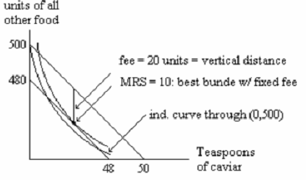

Senator Thomas dislikes the idea of a fixed fee and he proposes instead to simply tax each unit purchased of a teaspoon of caviar. Senator Thomas claims that so long as the correct tax rate is chosen the per-unit tax can be used to raise as much money as the fixed fee and will leave Sergei neither better off nor worse off than the fixed fee plan.

c) Suppose that the government chooses the value of the per-unit tax so that Sergei is indifferent between the bundle that he chooses under the fixed fee plan and the bundle that he chooses under per-unit tax plan. In a new diagram show that at this tax rate the government will raise strictly less revenue under the per unit tax plan than it did under the fixed fee plan. In your diagram be sure to include all three budget lines (no-tax line, fixed fee line and the per-unit tax line).

*Answer:*

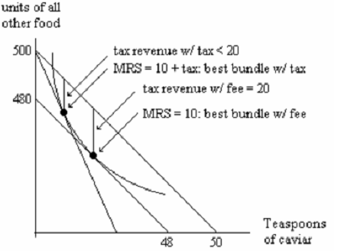

d) Suppose that the government chooses a value for the per-unit tax so that it will raise exactly the same revenue as the fixed fee plan. Briefly explain why Sergei will be strictly worse off with the bundle that he chooses under the per-unit tax plan than he was with bundle that he chose under the fixed feel plan. Illustrate your answer in a new diagram.

*Answer:*

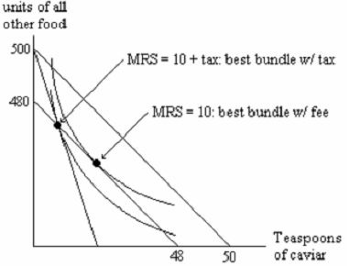

To levy the same amount of tax, the optimal bundle under the per-unit tax plan should be on the budget line under the fixed fee plan. At that point, the indifference curve should be tangential to the budget line under the per-unit tax plan.

It’s clear from the picture that this indifference curve is lower than the one under the fixed-fee plan. It is so because the relative price between caviar and other food also changed, the income effect for the per-unit tax plan is higher than $20 dollars if the same amount of tax being levied.

e) Suppose Sergei’s preferences can be represented by the utility function U(x,y) = xy. Write the 3 equations that can be used to determine the value of the per unit tax rate that would raise the same revenue as the fixed fee.

*Answer:*

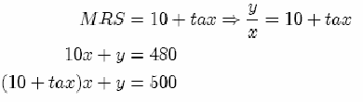

3. In September 2000 Laura went to college. Her parents gave her $120 per semester to spend on beer and movies. Laura’s preferences can be represented by the utility function U(x,y) = x +8 **ln**y where x is the number of cans of beer she purchases and y is the number of movies she sees. In 2000 the price of a can of beer was $3 and the price of a movie was $8.

From now on, Laura will be called Jane. (We had an old solution in pdf version).

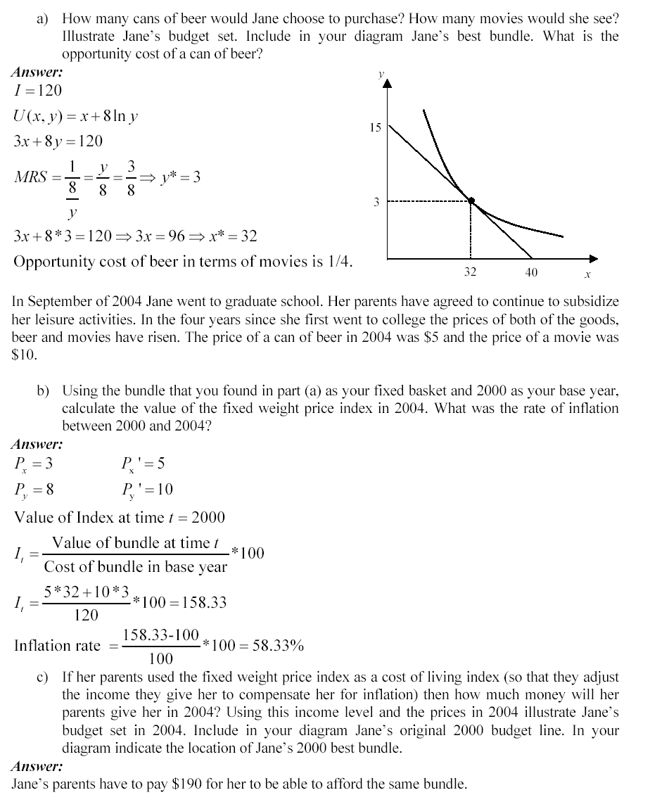

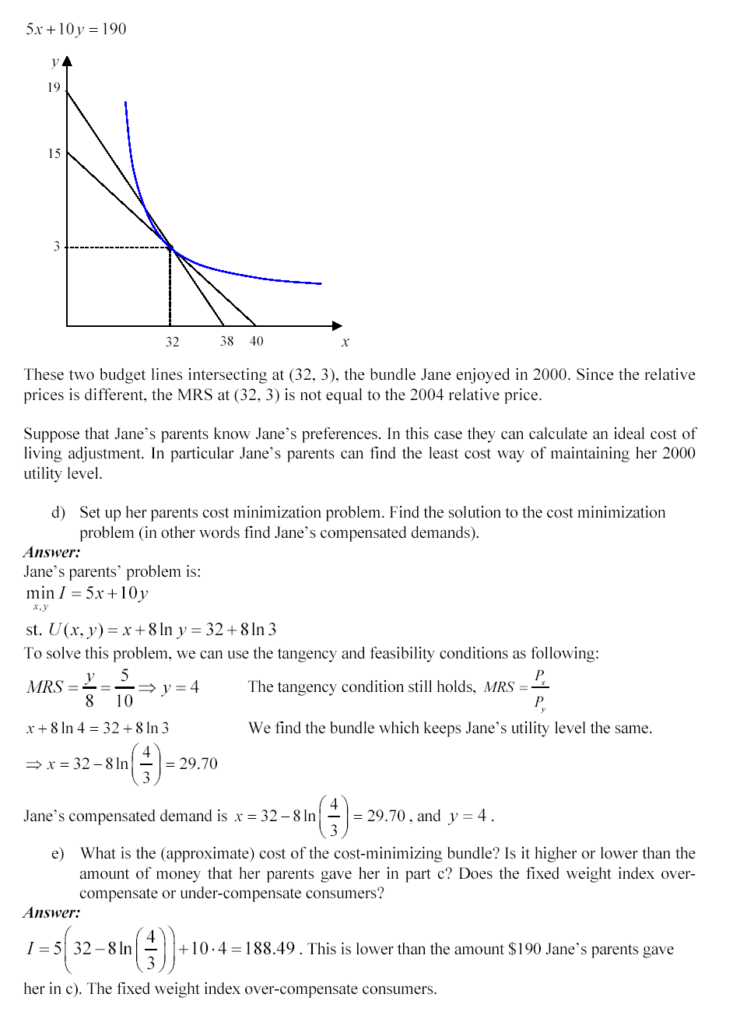

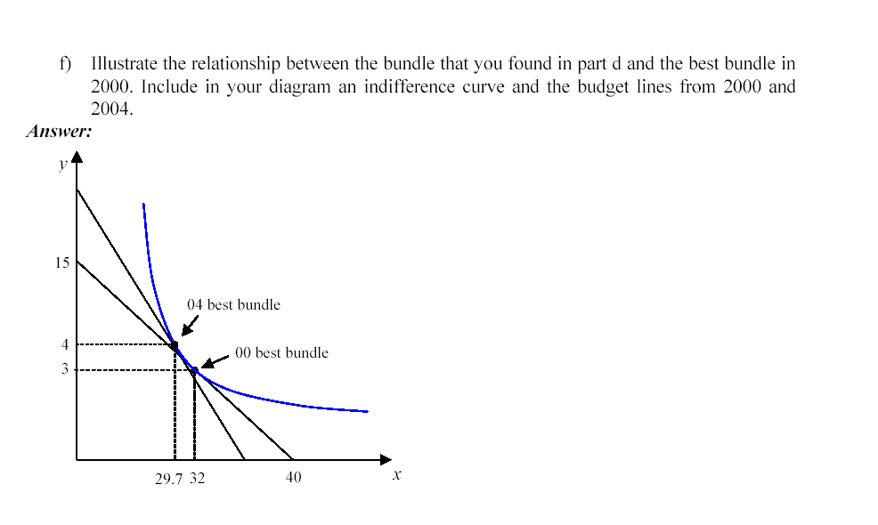

4. In order to aid the poor the government introduces a scheme whereby the first 2 lb of butter a family buys is subsidized and the remaining amounts are taxed. In other words if P is the original price of butter then a family pays less than P for each of the first two pounds and more than P for every pound purchased above 2 pounds. Illustrate budget sets before and after the government program. Consider a family that consumes butter and is made neither better nor worse off as a result of this scheme. Show that the total amount of tax any such family pays cannot exceed the subsidy it receives.

1. Budget set before and after the government program

Let Px be the original price of a lb. of butter, and Py = 1

Old budget line has the following equation:



As shown, the budget line under subsidy becomes flatter than the original budget line

(with no government intervention), and the budget line under the tax is steeper than the original budget line.



As shown in the Figure, this family is made no better or no worse off as result of this government scheme since they remain on the same indifference curve under both the old (no-government intervention) and the new budget line (subsidy for first 2 units and tax for all units after the second one).

If there was only subsidy to this family, the budget line would rotate and would extend to the dotted segment. However, when tax is added, the budget line rotates in at x=2 with a steeper slope. As such, the vertical distance from the taxed budget line to the original is the tax that this family pays. However, the vertical distance from the original budget line to the subsidized one is what this family gets from the government. As shown in the graph, subsidy > tax.



5. Suppose that Sheila has preferences represented by U(x,y) = min [3x, 2y] where x is the number of jars of peanut butter she consumes and y is the number of jars of jelly.

SEE BELOW.

6 Suppose that an individual consumes 3 goods, clothing (x), shelter (y) and food (z). The preferences over these three goods can be represented by the utility function .The prices of the three goods are Px,Py and Pz respectively. Find the uncompensated demands for the three goods. Hint: you can solve this two ways. One way would be to set up the Lagrangian and maximize it to solve for the 4 variables (x,y,z,λ). Alternatively you could use the budget line and calculate the MRS between each pair of goods and set each equal to the price ratio (this are our usual tangency and feasibility conditions).

Here’s the second way to solve the problem:

Ux = 1/3x, Uy = 1/6y, Uz = 1/2z.

This gives 3 tangency conditions: 6y/3x = Px/Py, 2z/3x = Px/Pz, and 2z/6y = Py/Pz.

These can be rewritten as y = .5x*Px/Py, z = (3/2)x*Px/Pz, and z = 3y*Py/Pz.

Plugging the first two into the budget line equation x*Px+ y*Py+ z*Pz = I gives

I = x*Px+ (.5x*Px/Py)*Py+ ((3/2)x*Px/Pz)*Pz = x*[1+ .5 + (3/2)]*Px= 3x*Px, so x* = I/(3Px).

Plugging MRS tangency conditions one and three into the budget line equation gives

I = (2y*Py/Px)*Px+y*Py+ (3x*Py/Pz)*Pz = y*[2+1+3]*Py= 6y*Py, so y* = I/(6Py).

Plugging MRS tangency conditions two and three into the budget line equation gives

I = ((2/3)z*Pz/Px)*Px+((1/3)z*Pz/Py)*Py+ z*Pz = y*[1+1]*Pz= 2y*Pz, so z* = I/(2Pz).

7. Suppose that we represent Herman's preferences for gallons of gasoline (the x-good) and burritos (y-good) with the utility function . The Marshallian demand functions associated with this utility function are given by the following demand functions:  and where Px and Py are the prices of gallons of gasoline and burritos respectively and I is the income he will spend per week.

1. If Px = $1, Py = $16 and I = $2880 then how many gallons of gasoline and burritos does he demand? Illustrate his best bundle below and label the bundle **A**.

Graphs are as in the exercise on expenditure minimization above.

The government decides to levy a per unit tax on gallons of gasoline. The tax rate is set at $7 per gallon.

1. What will be his best bundle after the tax raises the price to $8? Illustrate his new budget line and best bundle in your diagram. Label the best bundle **B**. What is the level of his utility at bundle B?

Utility is at 120*60*60=432000

1. How much revenue did the per unit tax raise? Illustrate these tax revenues measured in burritos in your diagram.

Government’s revenue: 120*7=840

Suppose instead of a per unit tax the government decides to levy a lump sum tax.

1. Assume that the government sets the lump sum tax equal to the tax revenues of the per unit tax. Illustrate in your diagram the effect of the lump sum tax on Herman's choice of best bundle. You do not need to calculate his best bundle. Label this best bundle C.
2. Write the expenditure minimization problem for Herman's utility function**.**
3. Solve for his Hicksian demands for gasoline and burritos as a function of prices and utility level.
4. Use your Hicksian demands to find a bundle, D, such that 1)Herman is indifferent between D and B; 2) Herman would choose bundle D at the original prices. What is the cost of D at the original prices? Illustrate bundle D in your indifference curve diagram.

Just substitute the prices and u=432000 from above.

1. What is the equivalent variation to the price changed caused by the per unit tax on gasoline? What is the excess burden of the tax on gasoline? Illustrate these values in your indifference curve diagram.

EV is a change in $ income that is equivalent in its effects to a change in price.

EV=Tax rev+excess burden.

1. What bundle of goods will Herman purchase if prices remain at their original value and his income was reduced by the equivalent variation that you calculated in part (h) above?

The same as after the price change.





